17. Managing Processes

Tasks

1. Open your Linux terminal and use the ps command to display all currently running processes for your user. Save the output to a file named my_processes.txt.

ANS:

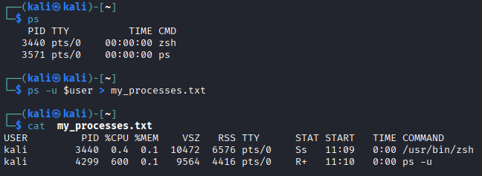

2. Start the Spotify client (or any music player app available on your Linux system), then use the top command to find its process ID (PID) and note it down. Look for the process name in the top list or use pgrep if needed.

ANS:

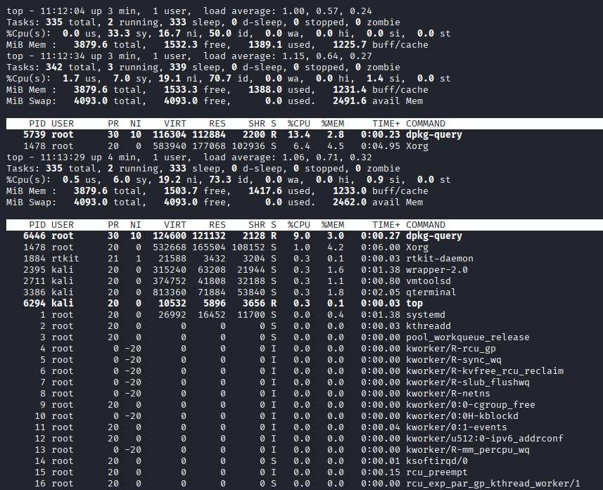

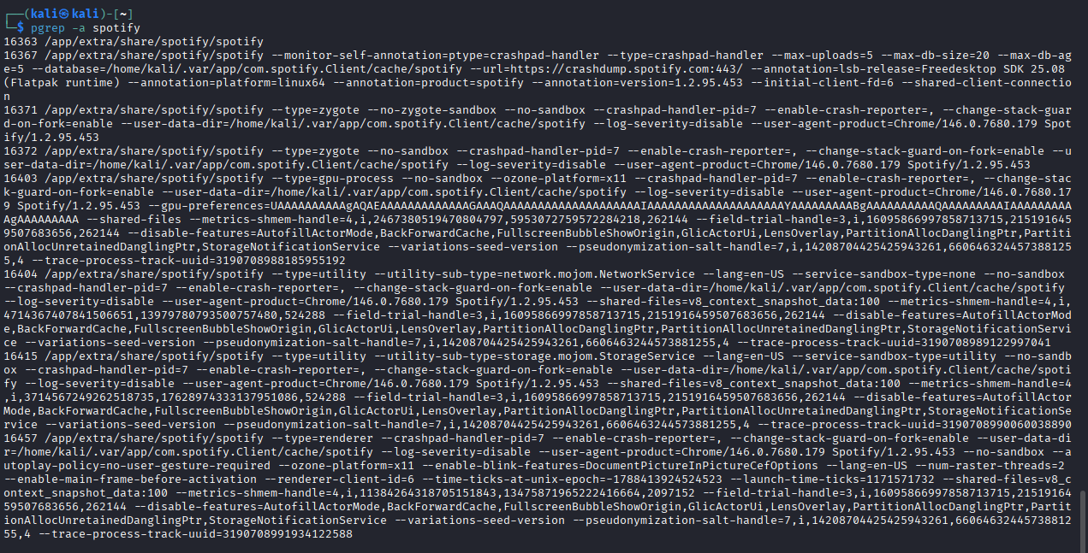

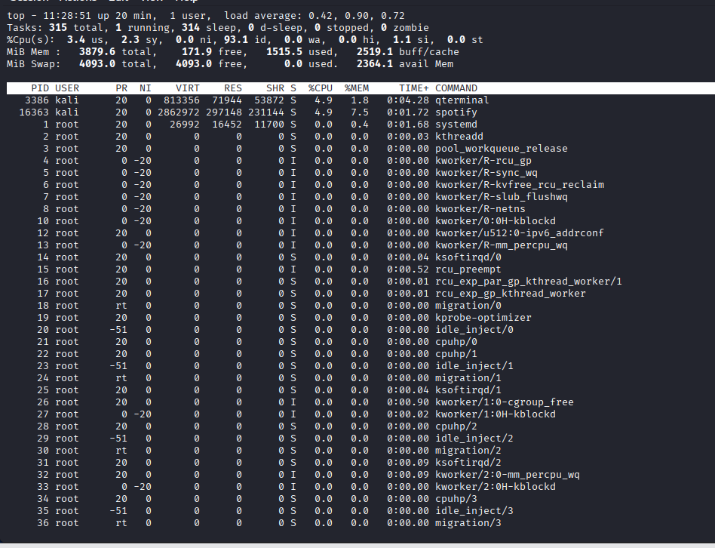

3. Use the kill command to terminate the process you found in the previous step. Verify that the process has stopped by running ps or top again.

ANS:

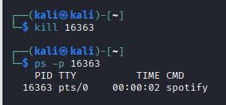

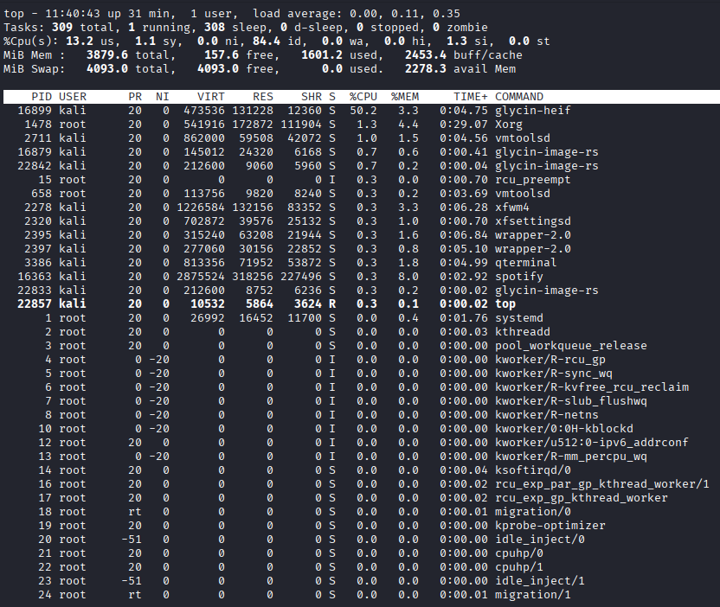

4. Run a long-running command like ping google.com in the background using &. Then, bring it to the foreground and stop it using Ctrl+Z and the fg command. Use the jobs command to see background jobs.

ANS:

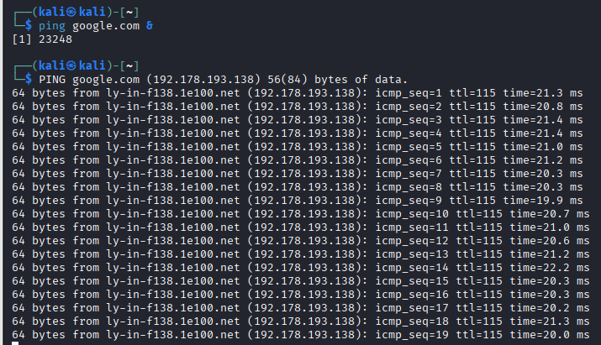
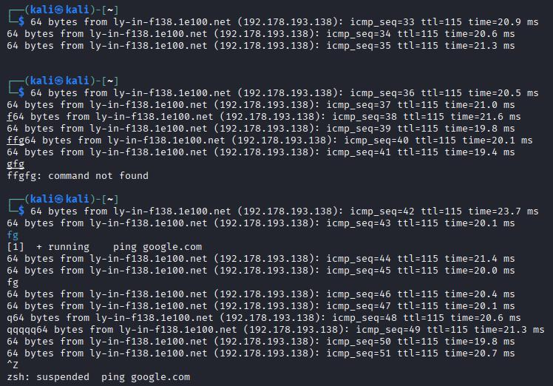

5. Suppose you accidentally started a heavy process that is slowing down your system (e.g., a big file copy or a simulation). Use the nice and renice commands to lower its priority and explain in one line how this helps system performance.

ANS:

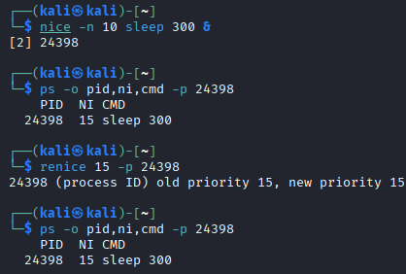

nice and renice reduce a process’s CPU priority, so other programs can get more CPU time and the system stays responsive.

